Sequence Diagrams

1

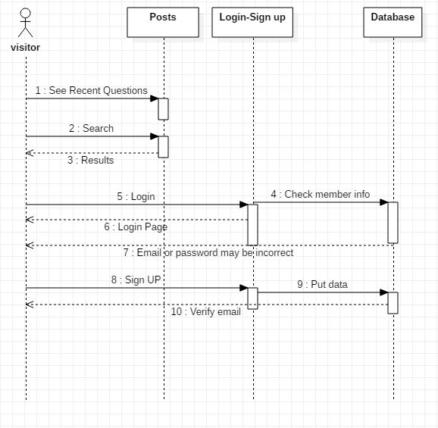

This diagram shows the sequence that the  normal visitor will take to access the website

2

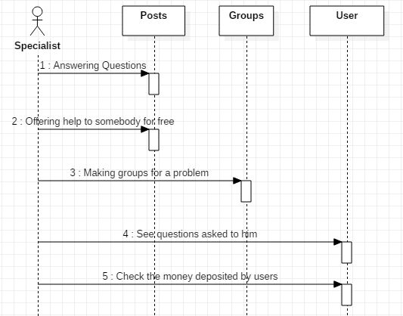

This diagram shows how the specialist work on the website

3

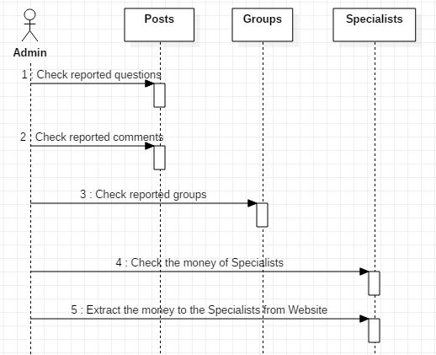

This diagram shows how the admin controls the website